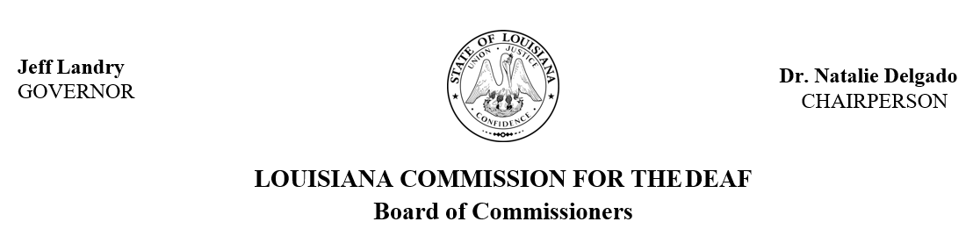

Friday, July 11, 2025
9:00 am - 1:00 pm
Louisiana State Capitol Senate Room AB

The state-mandated LCD Board meets quarterly to help guide program efforts and activities related to d/Deaf, DeafBlind and hard of hearing citizens of Louisiana

Live broad cast and caption link can be viewed on LCD’s website at the time of the meeting https://lcd.la.gov/commission-board/

Agenda

- Call to Order
- Invocation/Silent Prayer
- Pledge of Allegiance
- Roll Call; Introduction of New Member(s)
  - Vacancy Announcements
    - LCD Board has vacancies for a Deaf and a hard of hearing representative. If interested in learning more or to apply, please visit www.lcd.la.gov
- Mandate Review
- Public Comments
- Approval of Agenda
- Approval of Minutes
- Old Business
  - Proposed Rules for American Sign Language Interpreters- Notice of Intent Update
  - Strategic Planning
    - Report out from State Fiscal Year 21-24
    - Overview for State Fiscal Year 26-28
- New Business
  - LCD Sub-Committees- to determine creation of; to receive updates
    - Interpreter Advisory Committee
    - Board By-Laws Committee
    - Executive Committee
    - Mental Health Workgroup
    - DeafBlind Advisory Committee
  - Executive Director for LCD- receive program information on leadership structure; review job description
  - Vote for Vice Chair
- Public Comment
- Reports from LCD Director
- Reports from LCD Board Members
- Announcements
- Adjourn
Note: The order of the agenda may not be followed as listed in order to accommodate presenter schedules.

American Sign Language (ASL) interpreters and live captioning will be provided. Presenters, members, and guests may submit requests for additional accessibility and accommodations prior to a scheduled meeting. Please submit a request to jazmyne.lemar@la.gov at least one week prior to the meeting with details of the requested accommodations.

In lieu of verbal public comment, individuals may submit a prepared statement in accordance with Senate Rule 13.79. Statements should be emailed to jana.broussard@la.gov and must be received at least 24 hours prior to the meeting to be included in the record for the meeting.

To help us ensure our meetings are fully accessible, please share your meeting experience by completing this form https://redcap.link/iym5khet

RS 46: 2351-2355 Louisiana Commission for the Deaf

The commission shall be governed by a board which is hereby created as a separate and distinct body to support the work of the commission and to advocate on behalf of d/Deaf, DeafBlind, and hard of hearing communities and their families.

Title 67
SOCIAL SERVICES
Part VII. Rehabilitation Services
Chapter 3. Commission for the Deaf

§309. Louisiana Commission for the Deaf Board of Commissioners

The role and function of the Louisiana Commission for the Deaf board of commissioners are as follows:
- to support the work of the commission by making recommendations to the commission regarding its programs, policies, procedures, regulations, rules and criteria on behalf of d/Deaf, DeafBlind, and hard of hearing communities and their families
- to advocate for the general welfare, needs, and rights of d/Deaf, DeafBlind, and hard of hearing individuals in this state through education, advising, informing, and promoting relevant laws, policies, and practices which support the eradication of barriers and discrimination affecting individuals who are d/Deaf, DeafBlind, and hard of hearing.
- to create standing committees, ad hoc committees, or task forces as needed to assist in carrying out the above objectives.

